Michael Knight

Parallel Programming Skills Task 3:

**Defined Terms:**

Task – Is instructions given to the computer that the carried out by the processor.

Pipelining – Is a way to break down a task for a processor to use its multiple cores to carry out the task.

Shared Memory – Memory that is shared between all the processors.

Communications – Refers to the data that is exchanged in parallel programming.

Synchronization – Process that coordinates running at the same time or waiting until the rest is finished.

**Classify parallel computers based on Flynn’s taxonomy:**

SISD – Single instruction stream, Single data stream. One instruction, one data, oldest type of computer, Deterministic execution

SIMD – Single instruction steam, multiple data stream. All processing units execute the same instructions at any given clock cycle, each processing unit can operate on a different data element. Best suited for specialized problems characterized by a high degree of regularity.

MISD – Multiple instruction stream, single data stream. Each processing unit operates on data independently. Single data stream is fed into multiple processing units. Very few of these systems ever existed if any.

MIMD – Multiple instruction stream, multiple data stream. Every processor may be executing a different instruction stream; every processor may be working with a different data stream. Most common type of parallel computer.

**What are the Parallel Programming Models:**

Shared memory, threads, distributed memory, data parallel, hybrid, SPMD, and MPMD

**List and briefly describe the types of Parallel Computer Memory Architectures. What type is used by OpenMP and why:**

UMA – Uniform Memory Access. Share 1 general memory that can access multiple CPU

NUMA – Non-Uniform Memory Access. Several memories that are connected to several CPU

OpenMP was made for multi-core systems, both UMA and NUMA is used by OpenMP.

**Compare Shared Memory Model with Threads Model:**

**Shared Memory Model:**

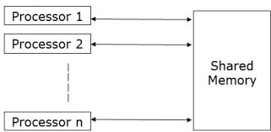

Each Processor has access to the shared memory which that can operate from.

**Threaded Memory Model**:

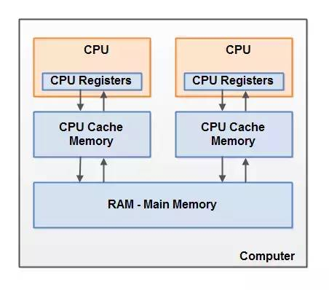Each Processor has access to their own memory that is used for them to carry out the task, while that “private” memory is connected to the shared memory so it can be updated with the results.

**What is Parallel Programming?**

Programming that brings out the most potential that’s possible out of a computer and all of its cores to reduce the amount of downtime or clockcycles.

**What is system on chip(SoC)? Does Raspberry PI use system on SoC?**

It’s a chip that has the CPU, GPU, and Ram all on the same chip. Yes Raspberry PI Uses this.

**Explain what the advantages are of having a System on a Chip rather than separate CPU, GPU and RAM components.**

Its more portable due to its size being smaller, and less expensive.

**Parallel Programming Basics**

2.1 : Made the following program

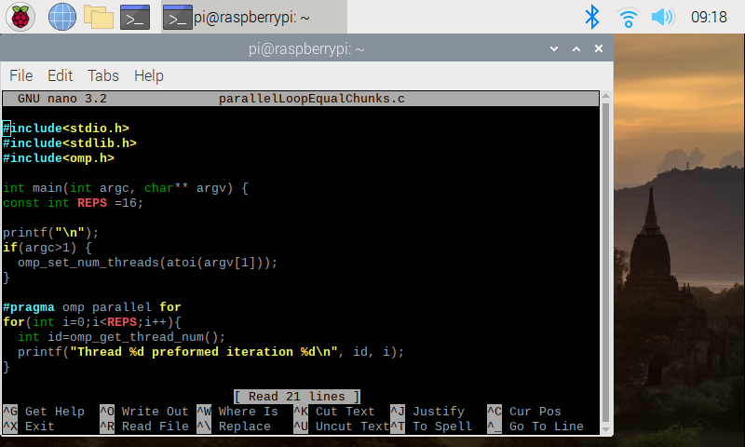

And ran it with ./pLoop 4:

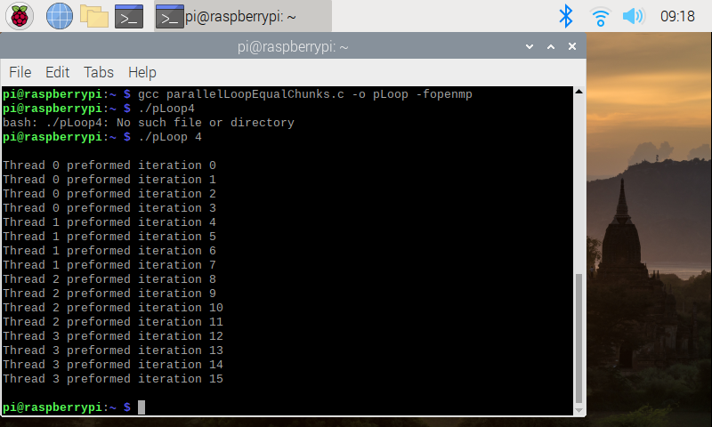

Then coded the next program parallelLoopChunksOf1and test the following: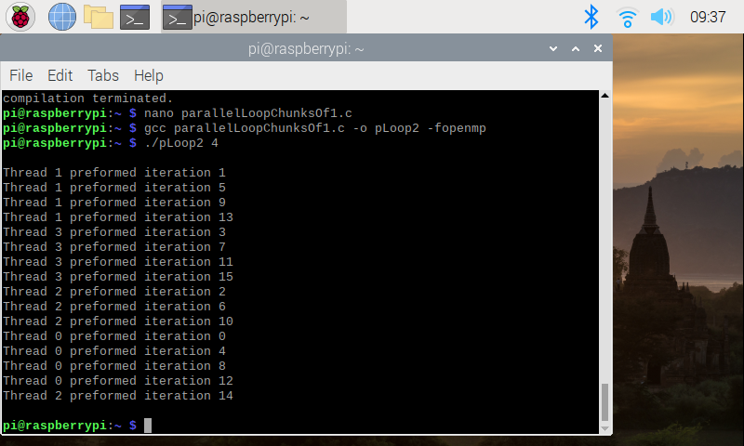

After uncommenting the section of code and running it again, I got the same result but in a different order.

Next was instructed to write the program Reduction.c

I was met with the following result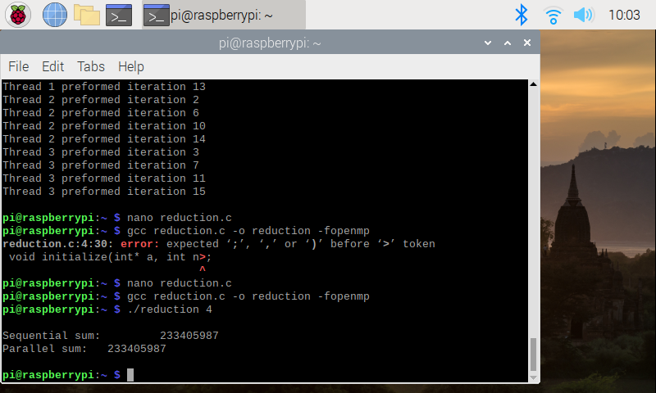

I then ran different numbers threw it:

